**02a.paradigms-knn, Tutorial 01 - The Learning Paradigms, and k-NN**

**Supervised**. In supervised learning, for each instance, we get a correct output.

**Unsupervised**. In unsupervised learning, we have no outputs (labels) given to us (the task is to explore and make groupings from the data based solely on the input).

**Reinforcement**. In reinforcement learning, we get some form of output but it does not correspond directly to the correct output for each instance. For example, we could get a single output after a batch of instances is processed (as commonly seen in games, where the eventual game win/loss outcome is the eventual output of a series of instance moves). For example, as a Year 1 student, I would like to choose modules that maximize my starting income upon graduation. If we consider the choice of modules during each of the nominal eight semesters as a problem instance, this would constitute a reinforcement learning problem. In this final task, the input might be the historical enrollment records of past students (and possibly their performance within each module), and the output would be their starting salary. Data is the set of inputs that correspond to the resultant output.

在强化学习中，我们得到某种形式的输出，但它并不直接对应于每个实例的正确输出。例如，我们可以在处理一批实例后获得单个输出（正如在游戏中常见的那样，最终的游戏赢/输结果是一系列实例移动的最终输出）。例如，作为一名一年级学生，我想选择能够最大化我毕业后起始收入的模块。如果我们将标称八个学期中每个学期的模块选择视为一个问题实例，这将构成一个强化学习问题。在这个最终任务中，输入可能是过去学生的历史入学记录（可能还有他们在每个模块中的表现），输出可能是他们的起薪。 数据是对应于结果输出的一组输入。

**k-Nearest Neighbors**

<https://zhuanlan.zhihu.com/p/71646003>

<https://en.wikipedia.org/wiki/K-d_tree#Complexity>

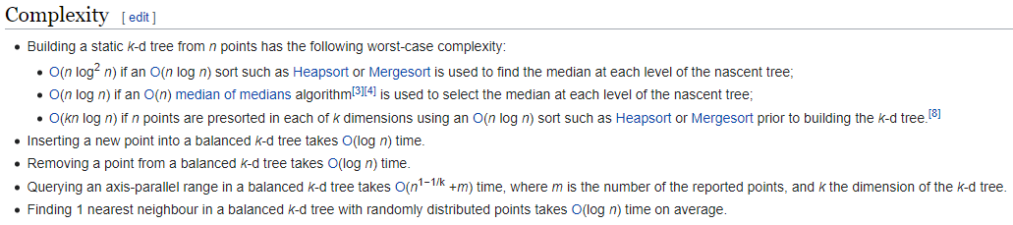

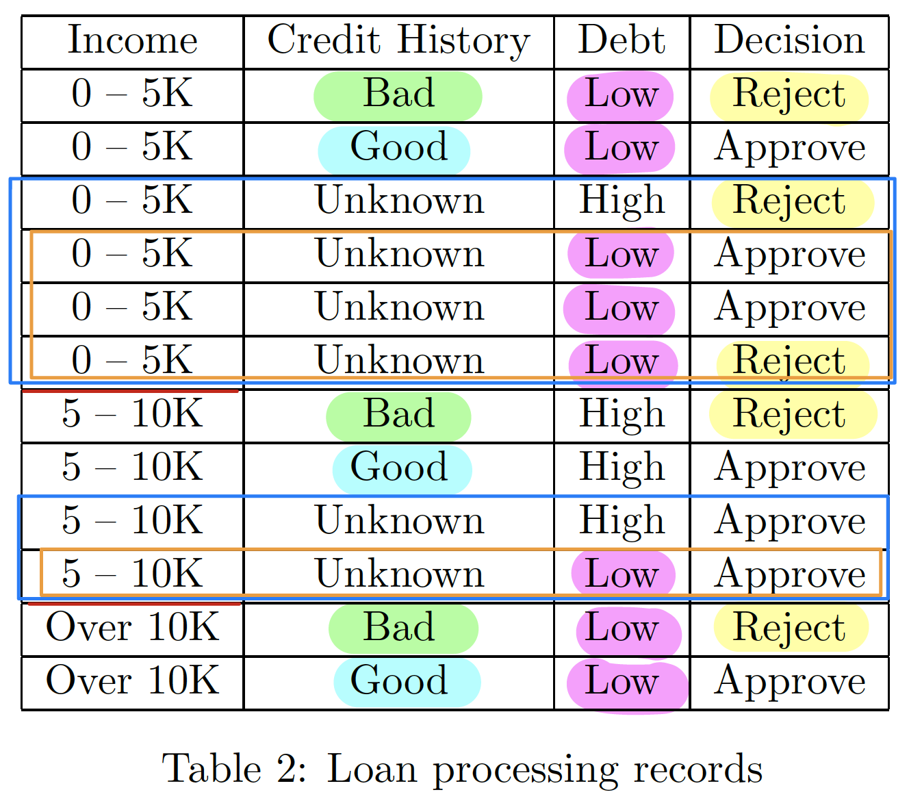

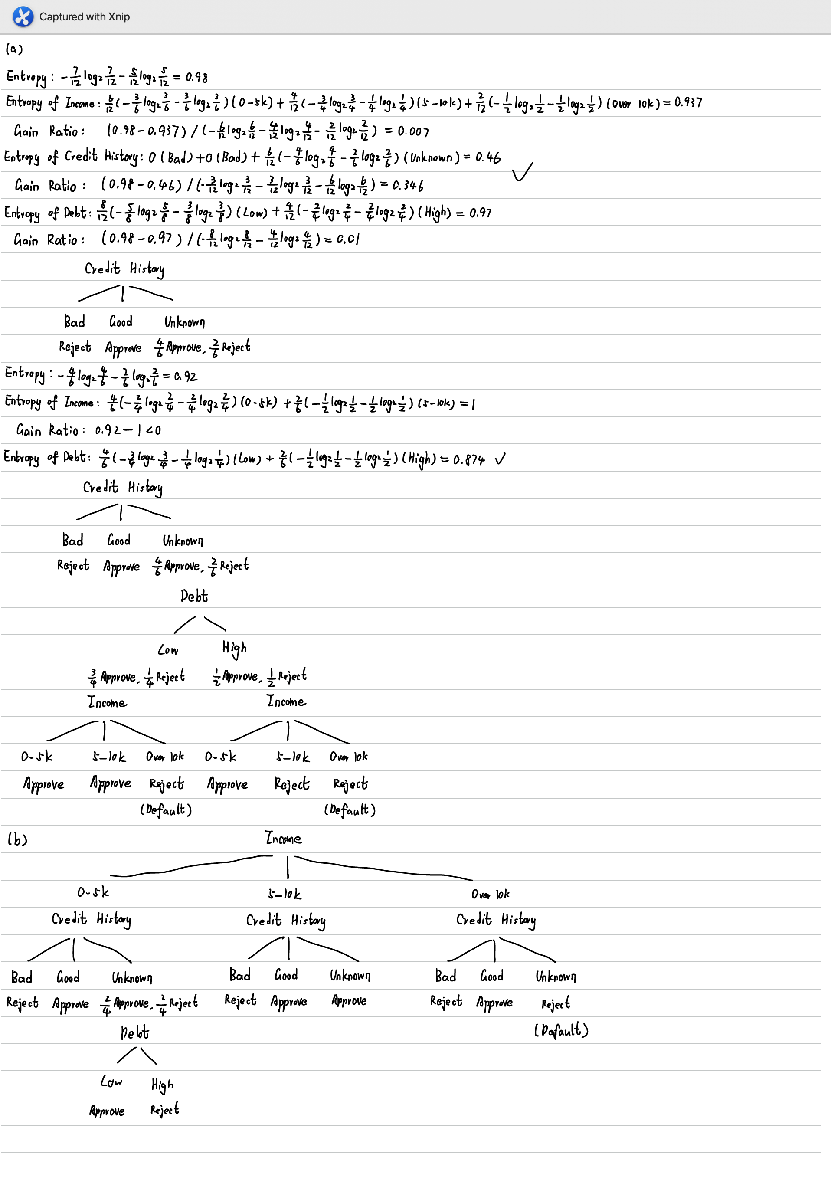

**07b.evaluations, Tutorial 05 Evaluation Metrics**

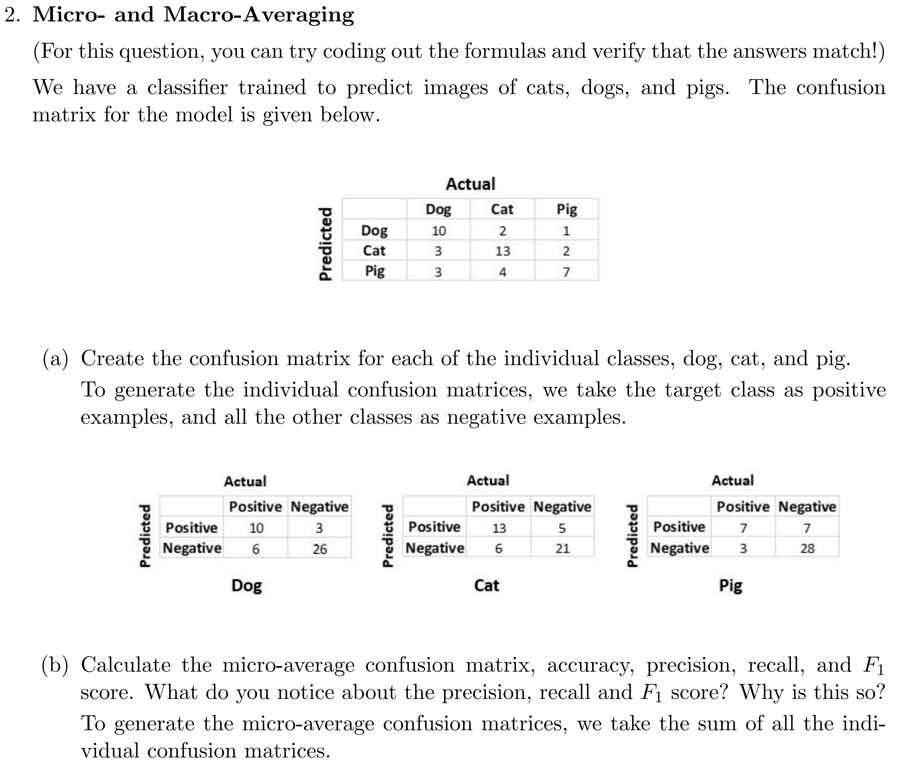

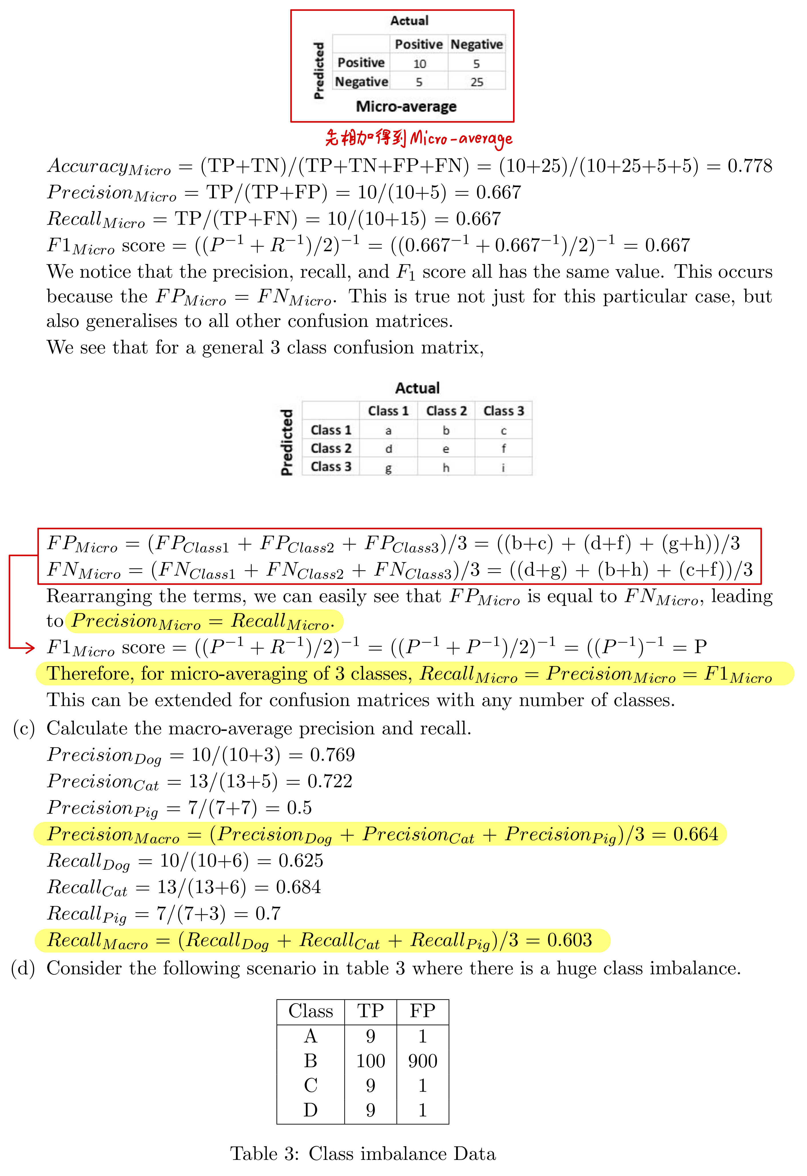

**07c.evaluations, 08a.data-processing, 08b.feature-engineering, tutorial-06:**

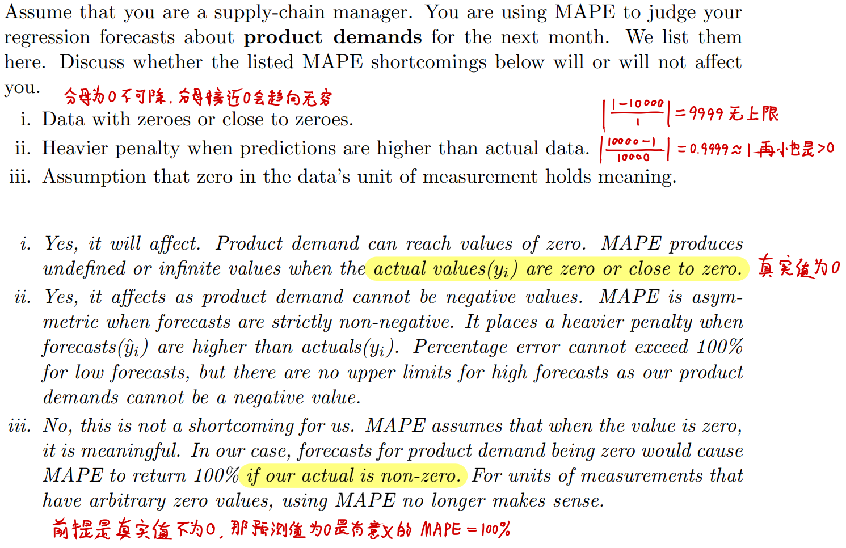

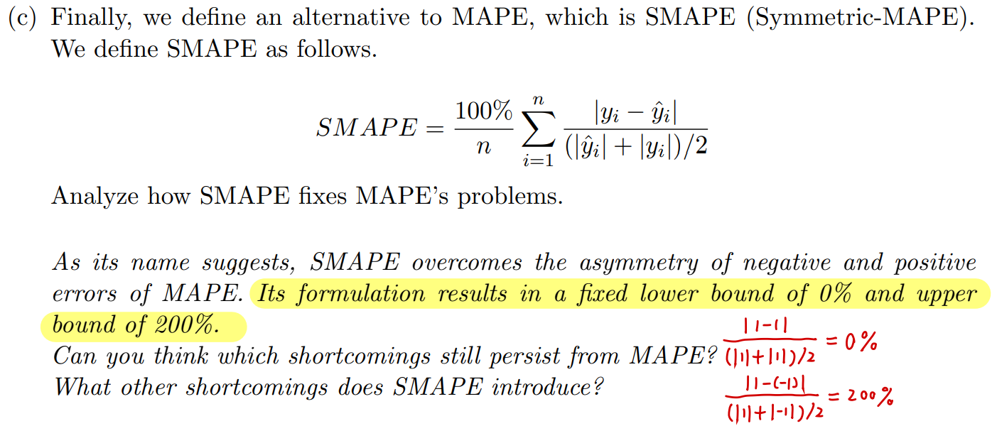

|  |  |
| --- | --- |
| MAE | <https://www.statology.org/mean-absolute-error-calculator/> |
| MSE | <https://www.statology.org/mse-calculator/> |
| RMSE | <https://www.statology.org/rmse-calculator/> |
| MAPE | <https://www.statology.org/mape-calculator/> |
| SMAPE | <https://rdrr.io/cran/Metrics/man/smape.html> |

**Feature Selection (Wrapper): Recursive Feature Elimination (RFE)**

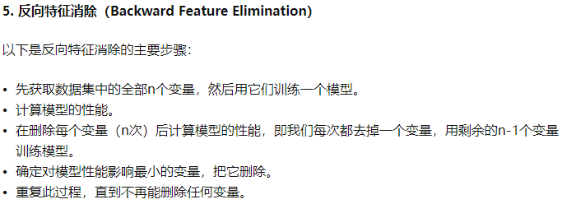

The graph peaked when only the top 3 features are considered. The score slowly decreases as additional features are added. **This is due to the fact that the latter features do not provide any further information. It is possible that they are a source of noise**, explaining the decrease in the score as more features are added.



**09a.perceptron-neural-networks, 09b.backprop-ama, tutorial-07:**

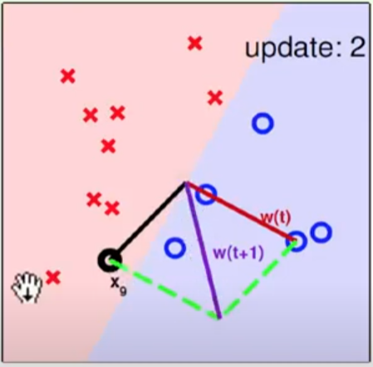 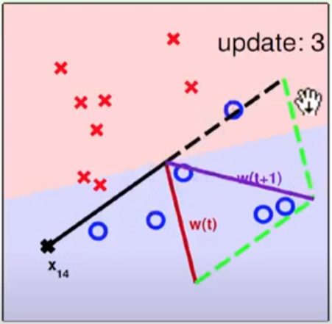

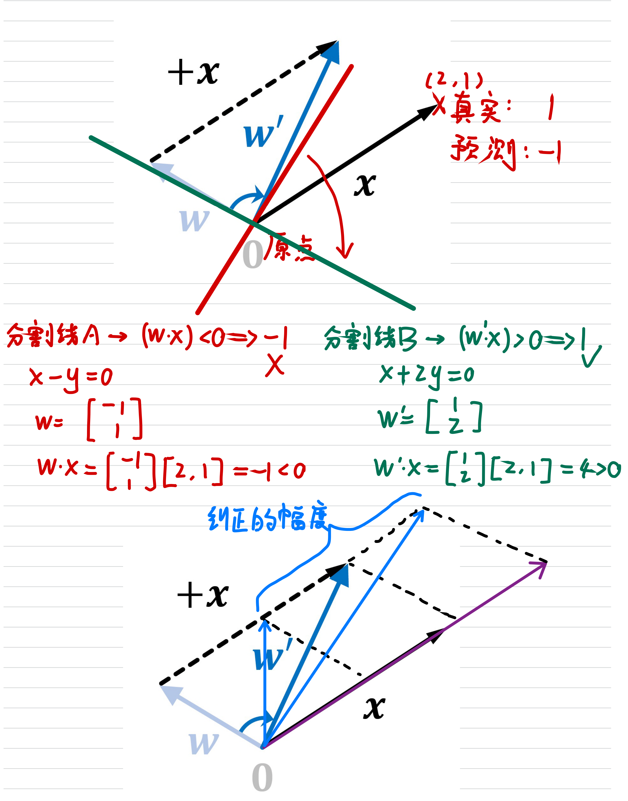

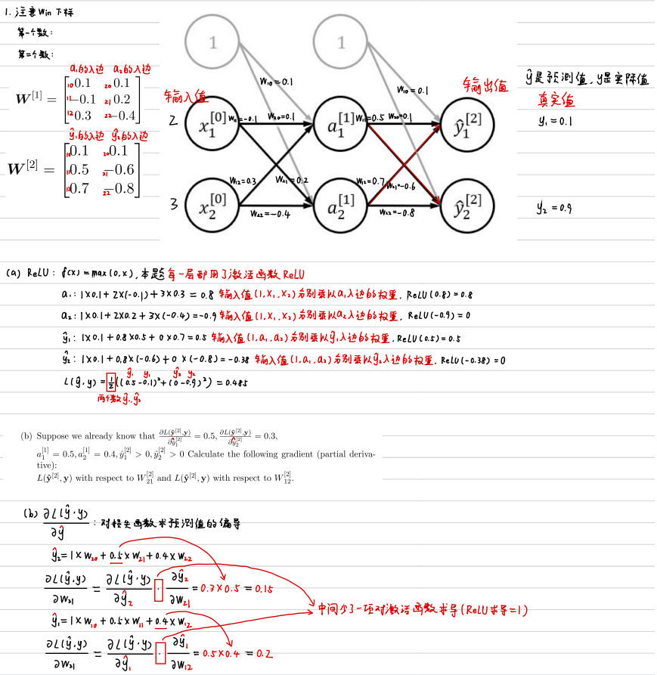

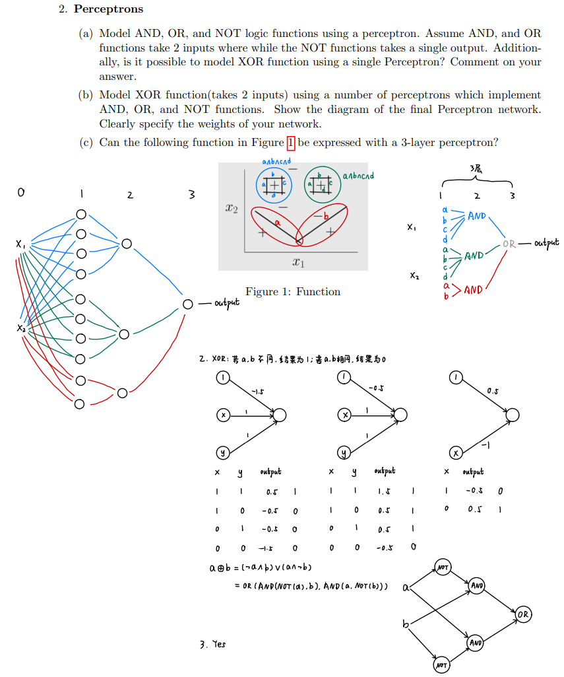

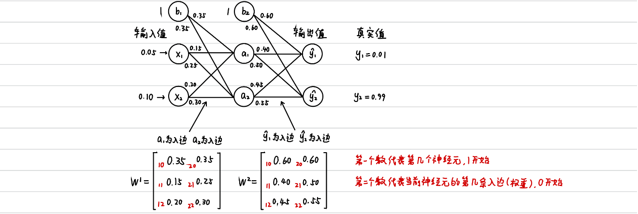

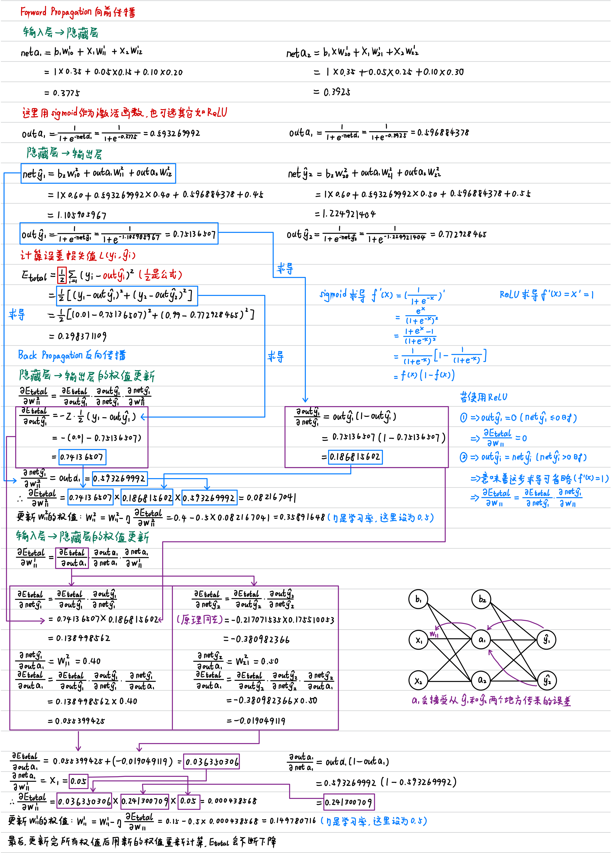

**10a.deep-learning-cnn, Tutorial 08 - Deep Learning**

feature maps其实就是一个理论意义上的图片，可能是512 * 512 * 3，可能是 256 * 256 * 10，就是长，宽，通道数的意思，但是就是每次经过卷积后的一个结果。

然后每次卷积前会把这个feature maps（这个图）丢进去，然后用kernel扫描，每个kernel扫描这个整个feature maps（这个图）就会得到一个2维的结果，因此这个kernel扫描的过程是扫描全部的通道然后再矩阵相加，所以最后成了2D的256 * 256 * 1的东西。

然后有n个kernel，例如10个，每个kernel扫描后的结果叠加一起，就成了256 * 256 * 10。

不断地重复这个3d到2d又到3d又到2d又到3d过程。

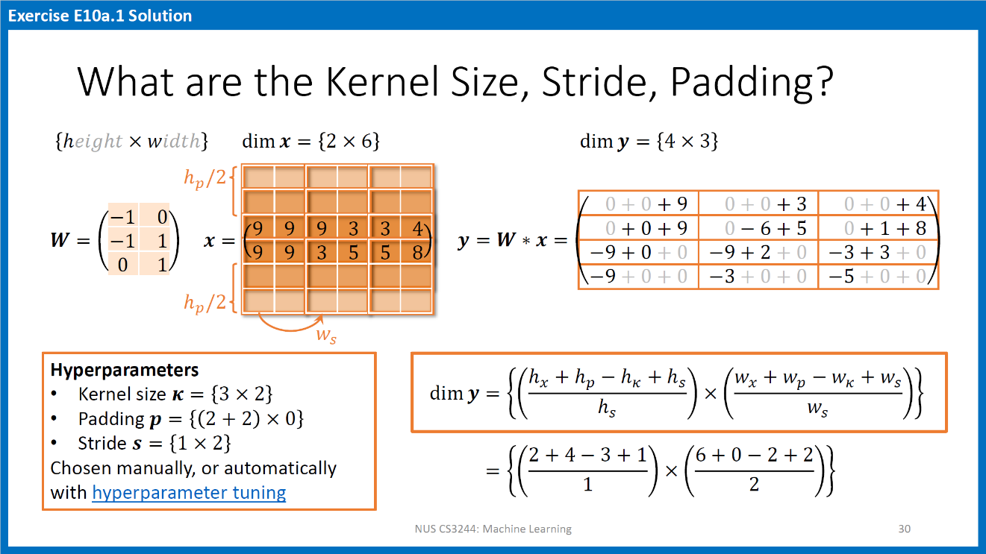

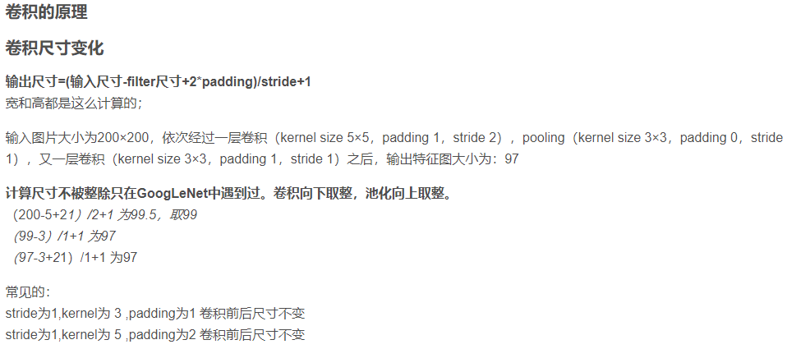

一个batch(B)的shape = B(可取8, 16, 32, 64等) X H(图像高度) X W(图像宽度) X C(通道数)

在 CNN 中，图像上堆叠两个卷积层，每个卷积层用的3X3 kernel扫描，而不是一个卷积层，用5X5 kernel扫描？一个5X5 kernel有25个参数，两个3X3 kernels有18个参数（一个3X3 kernel有9个参数），因此两个3X3 kernels的运算速度更快，而且一个5X5 kernel和两个3X3 kernels的视野（步长为1）是一样的。

You need a model to determine the sentiment of sentences (RNN, CNN)

You need a model to do translation between two languages (RNN)

**Tutorial 09 - RNN and XAI**

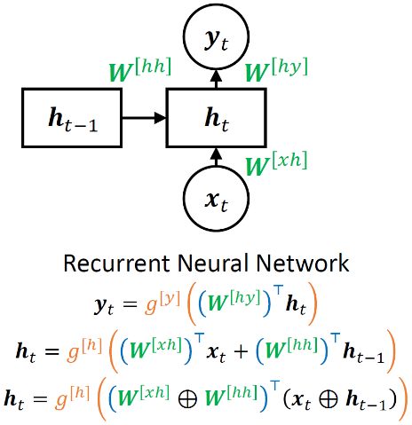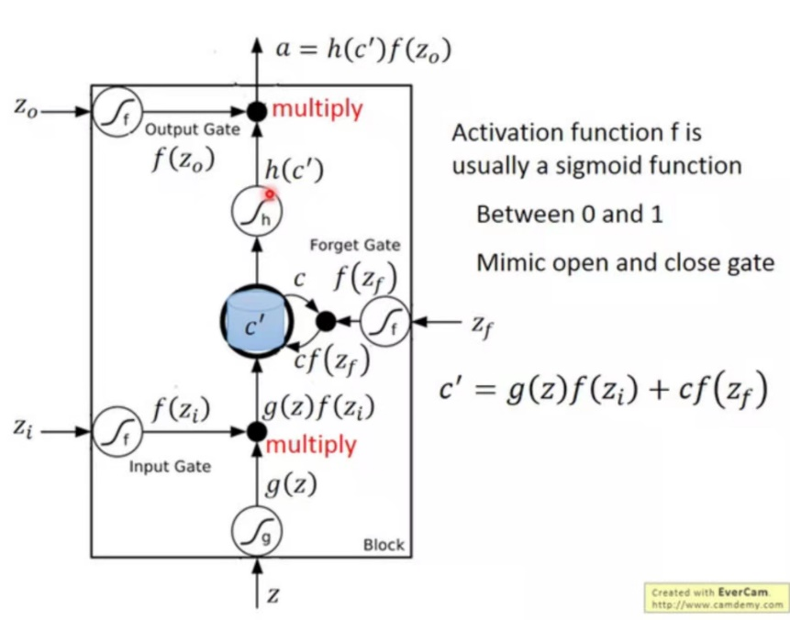

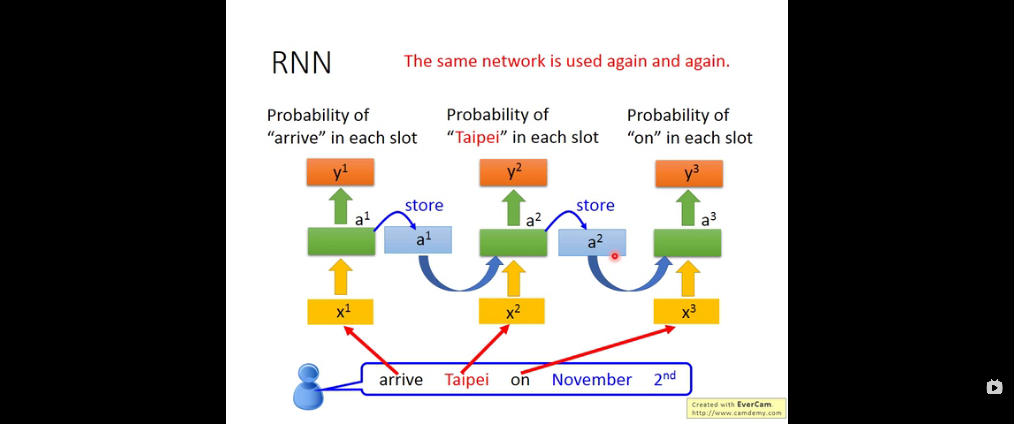

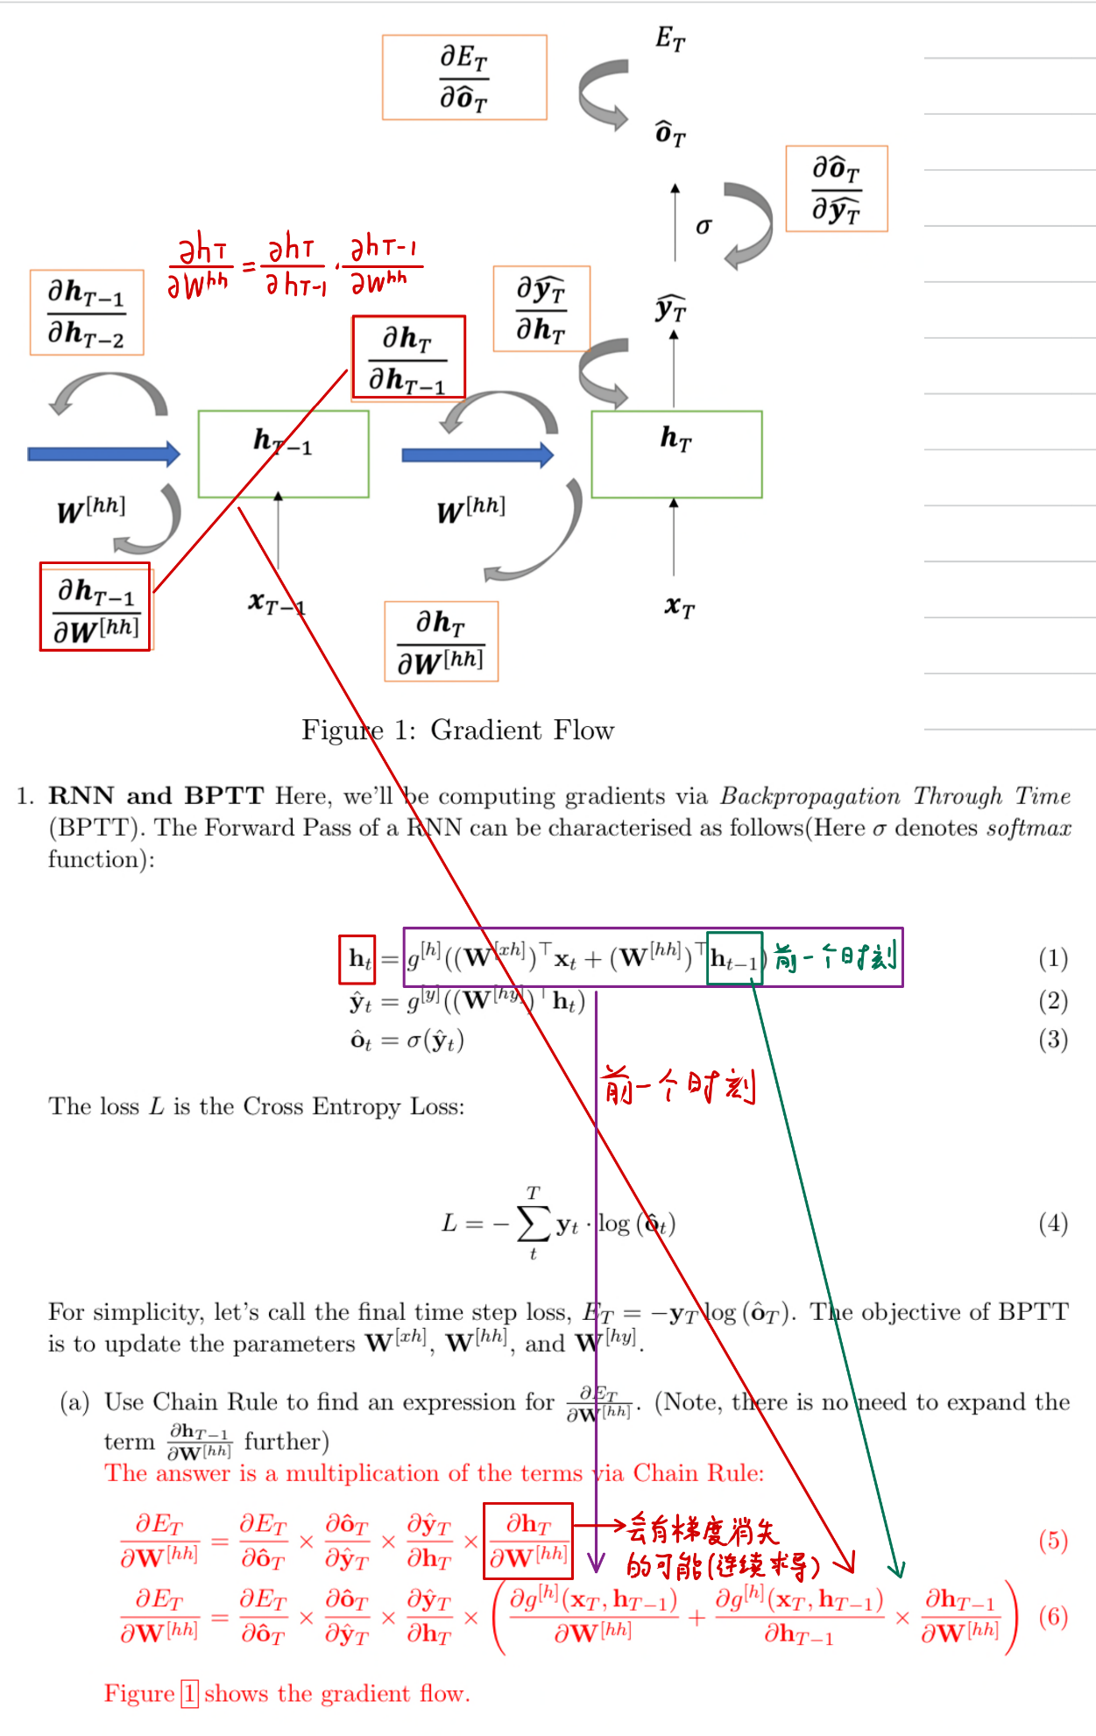

In LIME, we use a predictor which is a quadratic function rather than a line. How do you sample points for the decision boundary? Show how quadratic LIME can improve over a linear LIME.



What are the disadvantages of using LIME for explanation?

* Finding a proper neighborhood is difficult. For every new region, we may have to find new kernel widths. 很难找到合适的邻居。 对于每个新区域，我们可能必须找到新的内核宽度。
* Repeating the sampling process can produce different explanations. 重复抽样过程会产生不同的解释。
* Locally perturbed data may not be realistic. 局部扰动的数据可能不现实。

